**SCADA b,fvJ?bmvJ**

1/SCADA **qdkwm** Supervisory Control And Data Acquisition **vdkUac: ygw,f?t"dyÜg,fuawmh** Control System **awGtoHk;jyKwJh puf&Hk? tvkyf&Hk? vQyfppf"mwftm;ay;pepfawG ESifh pufrIvkyfief;awGrSm MuD;MuyfrI tenf;qHk;ESifh tcsuftvufawG&,lEdkifr,f?tcsuftvufawGxdef;odrf;r,f?udk,fvdkcsifwJh**Data **tcsuftvufawGudkjyefxkwfay;EdkifNyD;cdkif;apEdkifwJh** System **wckjzpfygw,f/** SCADA System **onf,ckESpfawGtwGif;rSm** Physical Experiments **awGvdk &IwfaxG;wJh** Control System **ESifhtdrfaxmifrIvdktyfcsufawGudk taxmuf tuljyKEdkifjyD;? puf&Hk? tvkyf&HkawGomru? "gwfcGJcef;awG? aq;&HkawG&JU**Cooling System , Venlation **tp&SdwJh** Performance **taeESifhygtoHk;jyKvmEdkifygw,f/**

2/ **SCADA System udkatmufygtwdkif; yHkpH(3) rsdK;eJYwnfaqmufEdkifygw,f/**

(u) D+R+N (Development+Run+Networking) vdkUac:wJh uGef,uf awGcsdwfquf?wnfaqmufNyD;vkyfaqmifjcif;?

(c ) R+N (Run+Networking) vdkUac:wJh uGef,uf awGcsdwfquf vkyfaqmifjcif;?

(*) Factory Focus vdkUac:wJhpuf&Hk? tvkyf&HkawG&JU t"dutcsuftcsm tjzpf wnfaqmuf jcif;wdkUjzpfygw,f/

3/ **t*Fg&yfrsm;(Feactures of SCADA)**

SCADA Control System wGift*Fg&yfrsm;taejzifh atmufygtwdkif; (10)ck&Sdygonf-

(u) Dyanamic process Graphic

(c) Alarm Summery

(*) Alarm History

(C) Real time trend

(i) Historical time trend

(p) Security (Application Security)

(q) Data base connectivity

(Z) Device connectivity

(ps) Scripts

(n) Recipe management wdkUjzpfygw,f/

4/ **Manufacture of SCADA(xkwfvkyffonfhae&mrsm;)**

Modicon (Telemeconique) Visual look

Allen Bradly: RS View

Siemens: win cc

Gefanc:

KPIT:ASTRA

Intelution:Aspic

Wonderwave:Intouch wdkUjzpfygw,f/

5/ **Evolution of SCADA (rsdK;qufrsm;)**

SCADA system onf atmufygtwdkif; rsdK;quf(4)ck ajymif;vJjzpfay:cJhw,f/

(u) **First Generation(Monolithic)/** tapmqHk;xGuf&Sdvmaom SCADA System onf Network System ryg&Sdao;aMumif;awGU&Sd&onf/

(c ) **Second Generation(Distributed)/** þ Generation wGif Lan csdwfqufrI pepfyg0ifvmNyD;? Information & command process rsm;tm; multiple Station rsm;odkYjzefYusufvkyfaqmifvmEdkifonfudk awGU&onf/ odkUaomf Security ydkif;wGiftm;enf;aeao;onf/

(* ) **Third Generation(Networked)/** Third Generation wGif Lan Network wpfckxufydkrdkyg0ifNyD; Process control network (PCN) wpfck jzpfvmcJhonf/

(C) **Fourth Generation(Internet of Things)/** Fourth Generation tydkif;wGif Maintaince & Integration tydkif;rsm;yg0ifvmNyD; Instruction & Components rsm;onfvnf; ydkrdk Economically jzpfvmcJhonf/ xdkYjyif Data rsm;vnf; Real Time tcsdefESifhwajy;nD Control jyKvkyfvmEdkifwmudkawGU&ygw,f/

6/ **SCADA Architecture (zGJUpnf;wnfaqmufjcif;)**

SCADA System [m NyD;jynfhpHkwJh Control System wpfckawmhr[kwfyg?odkYaomf Control System wpfckvHk;udkxdef;ausmif;ay;Edkifrnfh Software package wpfckjzpfygw,f/ NyD;jynfhpHkwJh System wpfckjzpf&eftwGuf Hardware Module awGeJYcsdwfqufay;EdkifwJY PLC Control, RTUs(Remote Terminal Units) rsm;? Sensor rsm;? Human-Machine Interface System rsm;? Networking System rsm;jzifhaygif;pyftoHk;jyK&efvdktyfygw,f/ Hardware rSm Cilent Layer vdkYac:wJh vlawGESifhpufawG&JUwHkUjyefrI? Data sever Layer vdkUac:wJh Control System awGyg0ifygw,f/¤if; Cilent Layer ESifh Data Server Layer wdkUudk Networking taejzifh Lan ,Ethernet rsm;jzifhcsdwfqufxm;ygw,f/ Software Architecture taeESifh Server wpfck(odkU)wpfckxufydkwJh Server awGuae tcsdefESifhwpfajy;nDjzpfaewJh tajccH Data awGudk apmifhMunfhjcif;? a&G;cs,fjcif;? wGufcsufjcif;? alarm check jyKvkyfjcif;rsm;udk csdwfqufvkyfaqmif&rSmjzpfygw,f/ xdkodkUaqmif&Guf&mwGifvlESifhpufaomf vnf;aumif;? Server tcsif;csif;aomfvnf;aumif; csdwfquf&rSmjzpfygw,f/

RTUs pepfwGif telementry hardware ydkif;yg0ifNyD; digital data rsm;udk ay;ydkUEdkifonf/ xdkUtjyif Supervisory control rSay;ydkUonfh digital command rsm;udkvnf;vufcHNyD;xdef;odrf;xm;Edkifonf/ PLCs pepfwGifvnf; RTUs pepfuJhodkUyif jyKvkyfEdkifNyD; RTUs pepfxufydkíaumif;rGefonf/ PLCs onfwpfckxufydkaom Input/Output Data rsm;udk Programmable Language toHk;jyKí command ay;EdkifNyD; ydkrdkwdusonf/xdkUjyif Flexiable jzpfjcif;?aps;EIef;t&vnf;wGufacsudkufjcif;ponfh tusdK;aus;Zl;rsm;vnf;&&Sdaponf/

Human-Machine Interface(HMI) qdkonfrSm Human operator monitors ESifh SCADA csdwfqufxm;aom Field Device twGif;rS Process Data rsm;tjyeftvSefcsdwfqufxm;jcif;jzpfonf/ HMI onf System Data Base ESifh Program Data rsm;udk Supporting jyKvkyfay;jcif;jzpfonf/

**7/ MODERN SCADA SYSTEM**

PLC (Programmable logic controller)rsm;onf,ckacwfumvwGif puf&Hk?tvkyf&Hkrsm;wGif us,fus,fjyefYjyefY toHk;jyKvmMuonfudk awGU&onf/ xdkYjyif puf&Hk? tvkyf&Hk rsm;wdk;wufvmonfhtm;avsmfpGm Control system twGuf Controller rsm;ydkrdk vdktyfvmygw,f/ xdkYjyif Control System ESifh Controller rsm;onfvnf; t&G,ftpm; ydkrdk ao;i,fvmwmudkawGU&ygw,f/

PLC/DCS SCADA System \tm;omcsufrsm;rSm-

* Computer jzifhtvGefrsm;jym;wJY Data tcsuftvufawG ukd rSwfom; xm;Edkif ygw,f/
* tcsuftvuf Data awGudk User awGtaejzifh rnfonfhenf;jzifhrqdk jyoEdkfifygw,f/
* ¤if; Area wavQmufvnf;axmifaygif;rsm;pGmaom senser awGESifh system udkcsdwfqufEdkifygw,f/
* Operator onfvnf; rSefuefaom Data tcsuftvufawGudk Added jyKvkyfay;Edkifygw,f/
* Data Type awGudkvnf; RTUs rSpkpnf;EdkifrSmjzpfygw,f/
* Data awGudk &IaxmifhtrsdK;rsdK;rSjrifEdkifygw,f/

**tm;enf;csufrsm;rSm-**

* System onf panel &Sd sensor rsm;xufydkí&IyfaxG;apw,f/
* operator skill rsm;vnf;vdktyfygonf/ (Oyrm- system analysis programmer ).
* Sensor rsm;csdwfquftoHk;jyK&ef Wiring System rsm;vdktyfygw,f/

8/ **Web Access of SCADA System**

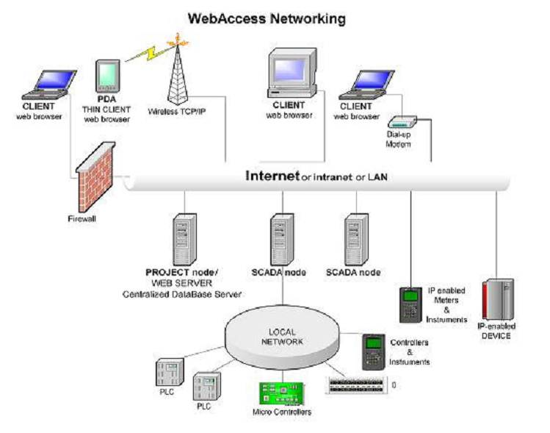

**SCADA System** rSm Standard Web Browser udktoHk;jyKNyD; Remote personal computer awGeJYcdswfquftoHk;jyKEdkifygw,f/ xdkUaemuf Project Node Server wpfckuae Internet(odkY)Lan system awGtoHk;jyKNyD; SCADA Node awGudk Link vkyfNyD;zefwD;Edkifygw,f/ Data Base wnfaqmufNyD; Project Node tjzpftoHk;jyKwJh Web Access Server udk Standard owfrSwfxm;aomfvnf; Version tvdkuftoHk;jyKEdkifonf/ SCADA Node awGuaewqifh Local Area Network toHk;jyKNyD; Automation Hardware awGjzpfwJh PIC,PLC,Controller, Input /Output Control ESifh Direct digital control System(DDC) awGudk Communicate jyKvkyfEdkifygw,f/

SCADA Node awG[m wpfckESifhwpfck oD;jcm;pDwnf&SdaeNyD; Display ESifh Runtime Data awGyg0ifygw,f/ Data awGeJY Alarm System Report awGudkawmh Project Node Server uae xdef;odrf;xm;ygw,f/ Alarm System udk Web Access Program t& email aomfvnf;aumif;? Display jzifhaomfvnf;aumif; azmfjyrnfjzpfNyD; tcdsefESifhwuG record jyKvkyfxm;rSmjzpfygw,f/

9/ **Maintainance of Operator Station and Software**

SCADA System rSm Human Effect (odkU)tjcm; Interface wpfckaMumifh Error jzpfapEdkifygw,f/ xdkUaMumifh Fault jzpfygu atmufygtcsufrsm;udk Checking jyKvkyfoifhygw,f?

(u) Interface jzpfwJh Data Communication Link awGudk ppfaq;&ygr,f/

(c) Power Supply Circuit, Circuit Breaker rsm; MuHUcdkifrI? Alarm System MuHUcdkifrIawGudk ppfaq;&rSmjzpfygw,f/

(*) xdkUjyif Local Network rsm;? Cable rsm;? Internet(or) Ethernet Connection rsm; ppfaq;&ygr,f/

(C) xdkUaemuf vdktyfaom MuHUcdkifrItwGuf Daily,Weekly,Monthly, Annual ESifh tcgtm;avsmfpGm ppfaq;jcif;wdkUjyKvkyf&ef vdktyfygw,f/

10/ **Future Trend of SCADA System**

vuf&SdtoHk;jyKaeaom SCADA System &JU tem*gwf [m Company awG&JU xkwfvkyfEdkifrI tay:rlwnfaeonf/ aemufydkif; SCADA System awG[m ydkNyD; fiexiable jzpfvmw,f/ Application awGESifhtaevnf; Modified jzpfvmw,f/ Software awG[mvnf; Popular jzpfvm íydkrdk Economic jzpfvmNyD; Hardware Capacity awGESifhcsdwfquf toHk;zdkU ydkrdk vG,fulvmwmawGU&ygw,f/ Hardware ydkif;wGifvnf; Super Smart Sensor rsm;ay:aygufvmwJhtwGuf t&G,ftpm;ESifh aps;EIef; udkavsmhcsvmwmudkawGU&ygw,f/ Wire System toHk;jyKjcif; avsmhusvm onfhtjyif powering circuit twGuf vdktyfaom Hardware rsm;vG,fulvmygw,f/

xdkUaMumifh SCADA Controlled System onf puf&Hk?tvkyf&Hk rsm;omru Home architecture system twGufygtoHk;jyKvmMuonf/xda&mufaom Operator ESifh Machine wdkUrSvdktyfaom Data rsm;udkqHk;jzwf? rSwfwrf;wifNyD; Real Time trend &&Sdatmifaqmif&GufvmEdkifaMumif;awGU&Sd&ygw,f/